**Sequence Alignment with Dot Matrix & Visualization**

**Dot Matrix Method**

Compare two sequences by plotting one along the **x-axis** and the other along the **y-axis**.Place a **dot** wherever characters match.Continuous diagonal lines represent regions of similarity.

Think of “connect-the-dots.” A perfect diagonal = two sequences are nearly identical. Breaks = mismatches or gaps.

**Interpreting Dot Plots**

1. **Perfect diagonal line**: high similarity (identical or closely related sequences).
2. **Parallel diagonals**: repeats or duplications.
3. **Broken diagonal**: mutations (insertions, deletions, substitutions).

Example:

* Sequence 1: **ATGCT**
* Sequence 2: **ATGAT**

Plot shows 3 dots in a row (ATG match), then break (mutation).

Related concepts for Dot Plot:

1. Window size – Number of nucleotides compare each time. (usually odd number)
2. Stringency – the minimum number of nucleotides in the window must be ‘match’ so that a dot can be placed.
3. Mismatch limit – the maximum number of nucleotides in the window can be ‘not match’, so that a dot can still be placed.
4. Mismatch limit = Window size – Stringency

Example 1: Compare the following sequences and find the region of similarity between two sequences. (window size = 5, stringency = 3)

AGAGACTC

AGAGTGTG

**Step 1:**

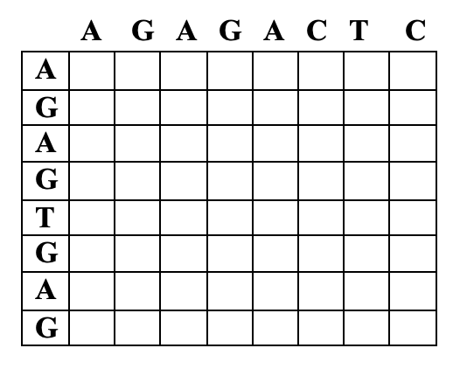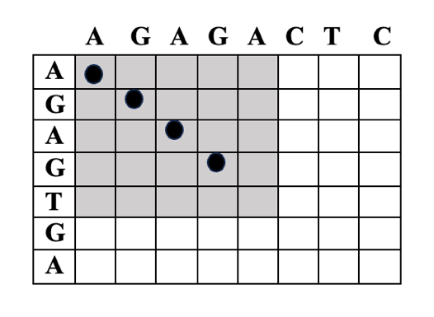

**Step 2 and 3:**

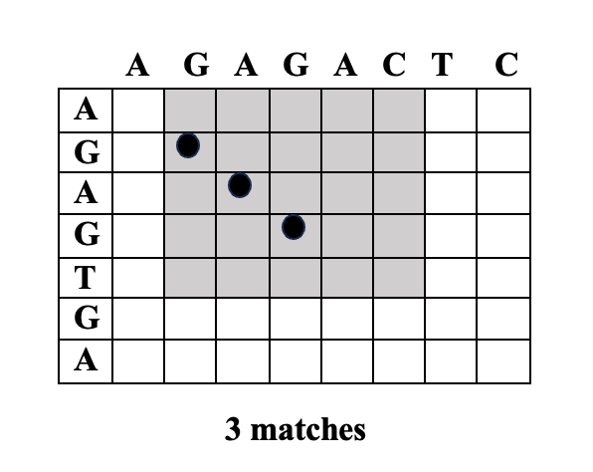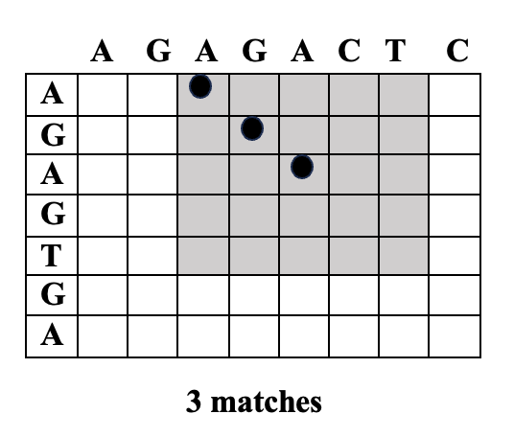

**Step 4:**

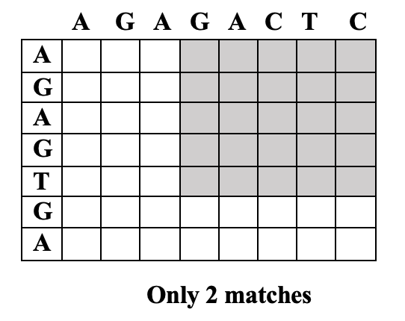

Example 2: Compare the following sequences and find the region of similarity between two sequences. (window size = 5, stringency = 3)

TGACCATGG

GGTACCAGC

**Alignment Visualization Tools**

* Software/tools:
  1. **Dotlet (Java-based)** – interactive dot plot.
  2. **NCBI BLAST Viewer** – graphical alignment.
  3. **UCSC Genome Browser** – large-scale sequence visualization.
* Importance: Makes raw alignment data understandable.

**Practical Session: Dot Plot Practice**

Generate and interpret dot plots.

1. Use **Dotlet** (or online dot plot tool).
2. Input two short DNA sequences, e.g.:

Seq1: ATGCTTAGC

Seq2: ATGCGTAGC

1. Observe dot plot → diagonal with small mismatches.
2. Modify one sequence (add insertion) → see how dot breaks.

task:

* Generate dot plot for human vs mouse insulin gene.
* Identify conserved (similar) regions.

**📝 Quick Review Questions**

1. What does a continuous diagonal line in a dot plot represent?
2. How can you detect insertions or deletions using dot plots?
3. Why are visualization tools important in bioinformatics?